WPG550*8
DIESEL GENERATING SET
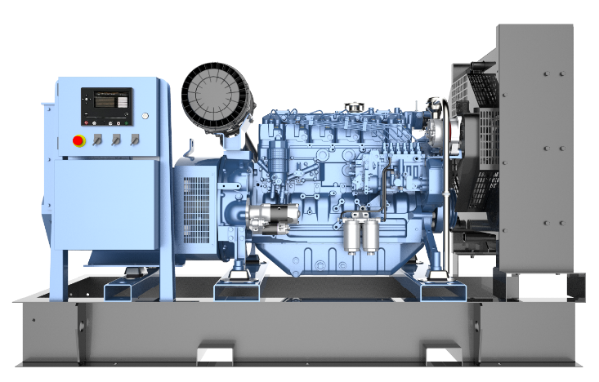

GENERATING SET RATINGS
50Hz – 1500rpm @ 0.8p.f.

Voltage | PRP |  | ESP
V | kVA | kWe | kVA | kWe
400/230 | 500 | 400 | 550 | 440

PRODUCT FEATURES

Engine
•Cast iron frame style body structure
•One-piece forged crankshaft
•Split-cap forged steel connecting rods
•Separate cast iron cylinder heads with 4 valves
•Replaceable dry cylinder liners
•Aluminum alloy pistons with oil cooling gallery
Cooling system
•Radiator and hoses supplied separately
•Thermostatically-controlled system with belt driven coolant pump and pusher fan
Fuel system
•High pressure Common Rail injection system
• Duplex fine filter and water separation filter assembly
with transparent cup for better efficiency
Lubrication system
•Flat bottom large capacity oil pan
•Spin-on full-flow lube oil filter

Electrical system
•24 Vdc electric starter motor and battery charging alternator
• LOP + HWT sensors
Air intake and exhaust system
• Mid-position and below inlet turbocharger optimized or genset application
• Special rear mounted air filter with restriction indicator
• Exhaust manifold shield for heat isolating
Alternator
•Brushless, 4 Pole, IP23 drip-proof revolving field design
•Class H insulation and Class H temperature rise
•Low reactance with 2/3 pitch windings on the stator
•Direct-coupled by flexible disc
•Sustained overcurrent >300% in 10 sec
•Direct drive centrifugal blower fan cooling
Control module
•DSE control module is ideal for a wide control range to manage, monitor, and diagnose quickly and easily.
•Display status message Provide protection Auto shutdown at fault detection

GENERATING SET SPECIFICATIONS
Governor and regulation class |  |  | In accordance to ISO 8528-5 Class G2 performance
Phase number and connection |  |  | 3 phase, 4 wires, Y-type
Cooling method |  |  | Closed looped water-cooled
Starting method |  |  | DC 24V Electric starter
Steady-state voltage deviation |  |  | ≤± 2.5%
Steady-state frequency band |  |  | ≤1.5%
ENGINE
Brand / Model |  |  |  |  | Weichai / WP13D490E310
Gross Power |  | kWm |  |  | ESP - 490 / PRP - 450
Cylinder / Type / Aspiration |  |  |  |  | 6 / In-line / Turbocharged and Aftercooled
Bore x Stroke |  | mm |  |  | 127 x 165
Displacement |  | L |  |  | 12.54
Compression ratio |  |  |  |  | 15.2:1
Brake Mean Effective Pressure |  | kPa |  |  | ESP – 3126
COOLING SYSTEM
Type of Coolant |  |  |  |  | Liquid (water + 50% antifreeze)
Total Cooling System Capacity (with Radiator) |  |  |  | L | 62
Max coolant temperature – shutdown |  |  |  | °C | 105
Cooling Fan Airflow |  |  |  | m³/min | 474
LUBRICATION SYSTEM
Operating Temperature range before Engine |  |  |  | °C |  | 78 -105
Oil fuel consumption ratio based on engine fuel consumption data |  |  |  | g/kW.hr |  | ≤ 0.2%
Total system capacity (including filters) |  |  |  | L |  | 38
Type of oil filter |  |  |  |  |  | Spin-on full flow filter

FUEL SYSTEM
Type of fuel filter |  |  | Spin-on fuel filter
Min. internal diameter of the supply pipe |  | mm | 14
Min. internal diameter of the return pipe |  | mm | 14
Max. fuel return restriction |  | Bar | 0.5
Max. fuel inlet temperature |  | °C | 50
Fuel supply flow |  | L/hr | 400
Fuel Consumption (Tolerance +3%)
Rating |  | gr/kWh |  | L/hr
100%ESP |  | 211 |  | 123.1
100%PRP |  | 204.3 |  | 109.5
75% PRP |  | 187.3 |  | 75.3
50% PRP |  | 190.5 |  | 51
25% PRP |  | 207.5 |  | 27.8
EXHAUST SYSTEM
Exhaust Gas temperature after the turbocharger |  | °C | 580
Exhaust Gas flow |  | m³/min | ESP – 114.8/ PRP – 102.3
Max. Exhaust back pressure |  | mBar | 120

ALTERNATOR
Brand / Model | WEICHAI / WHA-500-4/0.4 | LEROY-SOMER / TAL A473 C
Rated Current | 722A | 722A
Coupling / No. of Bearing | Direct / Single | Direct / Single
Winding Pitch | 2/3 | 2/3
Type of Excitation | Self-excitation | Self-excitation
Cooling type | Air | Air
Voltage regulation method | AVR | AVR
Insurance | Class H | Class H
Temperature rise | Class H | Class H
Protection Grade | IP23 | IP23
Efficiency at 0.8p.f.@100% load | 94.4% | 94.4%

CONTROL MODULE
Back-lit LCD display |  | 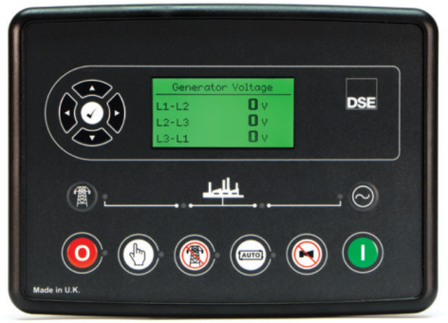
3 Phase generator and 3 Phase Mains monitoring
Monitoring speed, frequency, voltage, current, oil pressure, coolant temperature and fuel level
Display warning, shutdown and engine status information
Hours counter provides accurate information for monitoring and maintenance.

STANDARD CONDITIONS
Standard operating environment: ambient temperature is 5℃~40℃,the altitude is less than 1000m,the relative humidity is less than 90%(25℃),and there is no dust, sand dust, salt fog, mold, condensation environment, etc.
If the operating environment exceeds the above requirements, please contact the factory and consult.

Ambient adaptability protection measures for alternators
Ambient type | Ambient description | Measures of protection
General Ambient | The air is clean and dry, the humidity is ≤90%, and the distance from the coastline is ≥ 30km; Non-industrial ambient (chemical splash, acid-base steam, corrosive environment, etc.) | standard configuration
Humid Ambient | The humidity above 90% or condensation occurs | Anti-condensation heating
Salt spray Ambient | Salt fog crystals are produced in seaside (< 30km from the coastline) or island Ambient | Anti-condensation heating;  Spray three-proof paint on winding surface;  Spraying epoxy protection for parts and structures.
Dust Ambient | The ambient where mining, building construction, desert Gobi or sandstorm occur | Improve the protection level of the alternator to IP44;  Install filters.
If you need to use protective measures beyond the standard, please contact the factory and consult.

Special working condition
If the operating conditions of the generator meet the following conditions, please contact the factory and consult.
- Multistage parallel operation
- Grid-connected operation
- As the main power supply, it runs continuously for a long time
- The load includes a high power motor type load
- Capacitive load
- Special ambient such as high temperature, cold and plateau

Ratings definitions  Emergency Standby Power (ESP):  Emergency Standby Power is the maximum power available for a varying load for the duration of a main power network failure. The average load factor over 24 hours of operation should not exceed 70% of the engine’s ESP power rating.  Typical operational hours of the engine are 200 hours per year, with a maximum usage of 500 hours per year. This includes an annual maximum of 25 hours per year at the ESP power rating. No overload capability is allowed. The engine is not to be used for sustained utility paralleling applications.  Prime power (PRP):  Prime Power is the maximum power available for unlimited hours of usage in a variable load application. The average load factor should not exceed 70% of the engine’s PRP power rating during any 24 hour period. An overload capability of 10% is available; however, this is limited to 1 hour within every 12 hour period. | 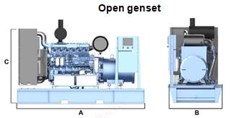  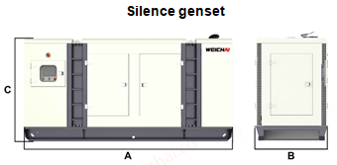
This outline drawing is to provide representative configuration details for Model series only.
See respective model data sheet for specific model outline drawing number.
Do not use for installation design
Ddimension and Weight
Structure | Model | Dim “A”  mm | Dim “B”  mm | Dim “C”  mm | Dry wt.*  kg | Fuel capacity*  L
Open | WPG550F8 | 3200 | 1396 | 2024 | 3280 | 440
Silence（Elite） | WPG550L8 | 4550 | 1550 | 2100 | 4280 | 710
Silence（Premium） | WPG550L8 | 4550 | 1550 | 2150 | 4280 | 408

* Note: Weights represent a set with standard features. See outline drawings for weights of other configurations.

Fuel capacity is the total capacity, including the fuel that cannot be pumped.

Codes and standards

ISO 9001 | This generating set is designed and manufactured in facilities certified to ISO 9001. | ISO 8528 | This generating set has been designed  to comply with ISO 8528 regulation.
 | The CE marking is only valid when equipment is used in a fixed installation application. Material compliance declaration is available upon request.

For more information contact your local Weichai distributor or visit www.weichai.com

